**Financial Account Information**

**Reporting Process**

*(Summary and Analysis)*

1. **Pre-Requisite**
2. The FI should successfully register to the AEOI Portal to get its **AEOI ID**.
3. **Filing Return for the Year Report**
4. To create a new *Return for the Year* report, go to **Export XML Page** -> **New Data** tab (*see Figure 1*). The user should enter the following required fields:
   1. **Return Year** - identifies the calendar year of the reporting period to which the message relates.
   2. **Accounts** – the accounts to be reported associated in a specific calendar year. The user selects from the list of accounts from the Accounts table.

The following fields are optional and may be used if necessary:

1. **Contact** - specific contact information for the sender of the message.
2. **Attention Note** - notes on matters requiring the attention of the recipient.

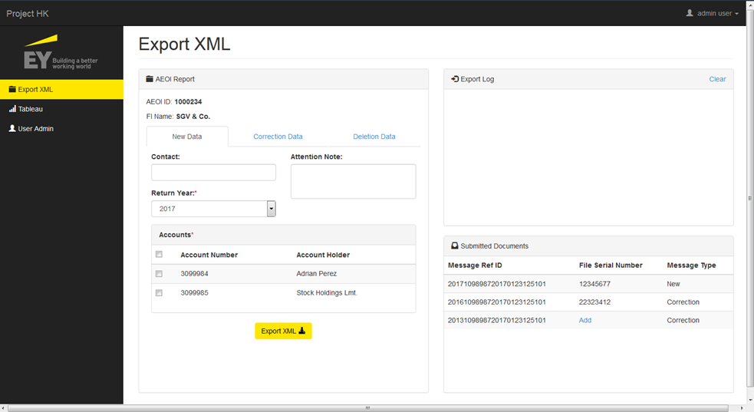

**Figure 1. Export XML (New Data)**

Upon clicking the *Export XML* button, the system will generate the XML document based from the schema provided and will automatically be downloaded. The document filename follows the following format:

**YYYYXXXXXXXYYYYMMDDHHMMSS99.xml**

* 1. The **first 4 digits** are the calendar year to which the message relates.
  2. The **next 7 characters** are the unique AEOI Identification Number (AEOI ID) that was allotted to each FI upon successful registration of its Account in the AEOI Portal.
  3. The **next 8 digits** are the file creation date starting with year then month then day (all single digit day or month dates should have a leading zero). Example: 1st April 2017 would be 20170401.
  4. The **next 6 digits** are the file creation time in hours, minutes and seconds.
  5. The **last 2 digits** are an incremental number (e.g. 00-99) starting from ‘00’ and increasing to ‘99’ when a file is produced during the same second.
  6. This name should also be used for the element “MessageRefId” in the XML message

1. Login to the AEOI Portal and upload the downloaded xml document.
2. Wait for the verification email together with the File Serial Number that comes along with it. This File Serial Number will be used if there are necessary corrections or deletions needed to be done.
3. File/submit the *Return for the Year* report.
4. **Correcting Return for the Year Report**

The correction of the report is done in two ways depending on the status of the uploaded *Return for the Year.*

1. **Return for the Year is not yet submitted/filed**

If the return for the year is not yet filed or submitted, the correction or deletion can be done through the following:

* 1. Delete the previously uploaded XML document file in the AEOI portal.
  2. Create a new xml document in the Export XML page of the web application (*as seen in Part II*) and re-upload it again in the AEOI portal.
  3. Wait of the verification email if the uploading of the document has been successful and accepted.

1. **Return for the Year is submitted/filed**

If the return for the year is already submitted and filed, the user needs to use the *Correction* and *Deletion* XML document type.

The details of the documents being downloaded in the web application is being tracked as seen in Figure 2. This contains the *Message Reference ID*, *File Serial Number* and *Message Type*. This is used as guide for creating Correction and Deletion XML document.

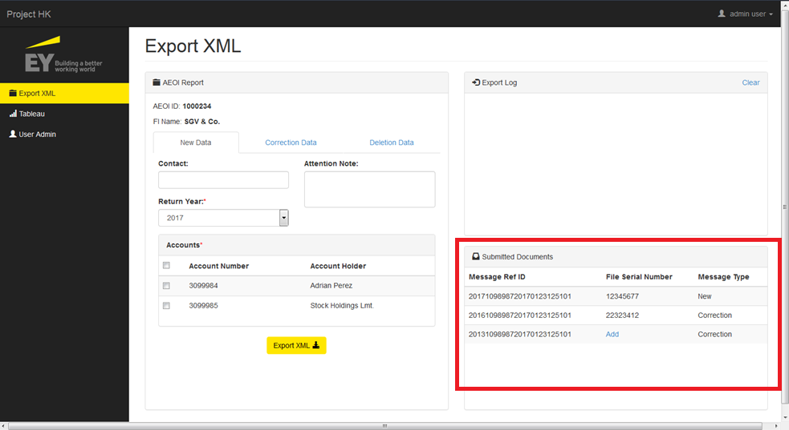

**Figure 2. Submitted Documents Table**

The *File Serial Number* of the uploaded file that comes with the verification email is a requirement for creating a Correction or Deletion document file. Because the File Serial Number is sent through email, the uploader must add the File Serial Number manually in the Export XML page (*see Figure 3*) for tracking purposes and if necessary corrections or deletions are needed.

Figures 4 and 5 shows the *Correction Data* and *Deletion Data* panel respectively. These two looks exactly the same but the type of message or document that will be produced is different and it will be taken care of by the system.

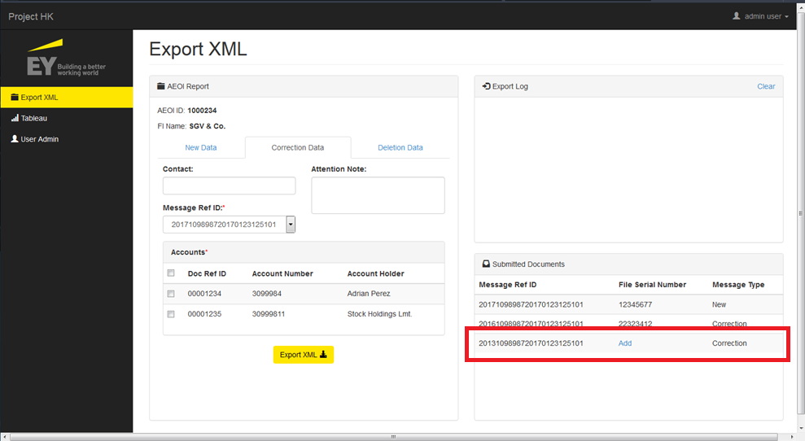

**Figure 3. Add File Serial Number**

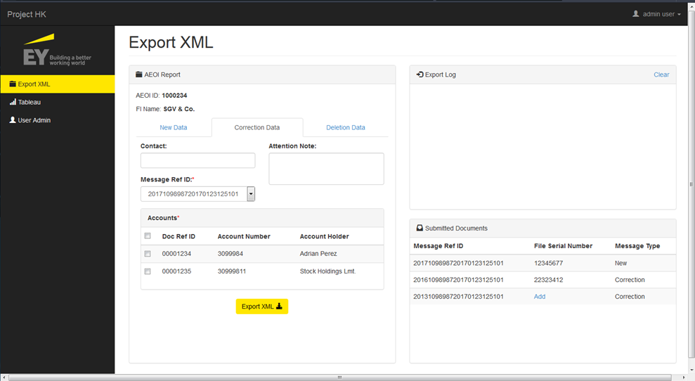

**Figure 4. Correction Data Panel**

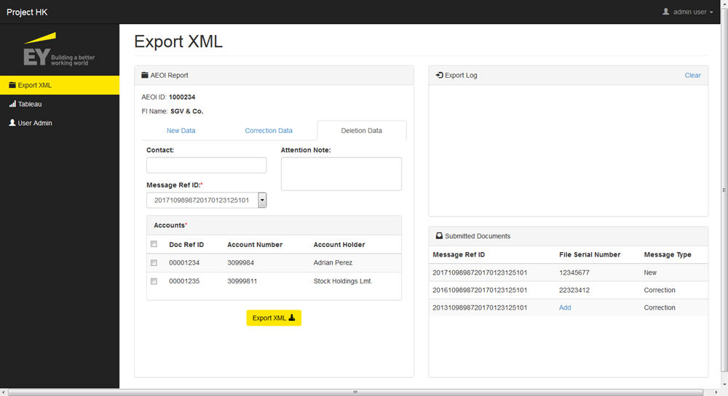

**Figure 5. Deletion Data Panel**

To perform correction or deletion, the user must do the following:

1. Select the *Message Reference ID* of the document that needed to be corrected from the dropdown list in the *Correction Data/Deletion Data* panel. Make sure that the File Serial Number of that document has already been input, as pointed out previously.
2. Under the *Accounts* table:
   1. For Correction Data, select the accounts where corrections are performed.
   2. For Deletion Data, select the accounts that are needed to be excluded from the previously submitted Return for the Year report.
3. Click the Export XML button to download the XML.
4. Upload the document to the AEOI portal and wait for the verification email.

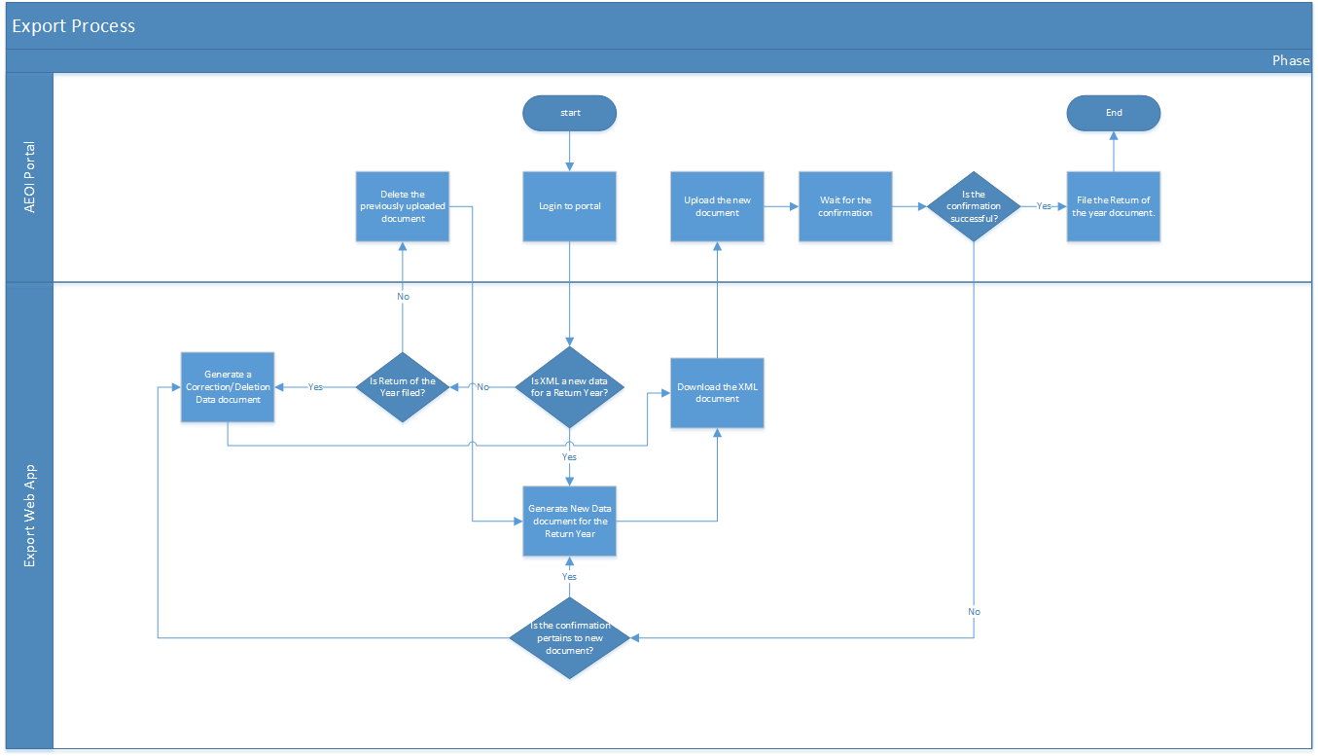**Figure 6. Flowchart of submitting Return for the Year report**